# *Systems III (420-E31-HR)*

# *Lab 7 – Black Box Testing Techniques*

Date assigned: Wed, October 18, 2017

Date due: **Wed, October 18, 2017, 12:00 p.m.**

**Learning Objectives**

Upon successful completion of this lab exercise, the student will be able to:

* Describe black box testing techniques
* Use equivalence partitioning and boundary value analysis to derive test cases
* Derive test cases from use case scenarios

To do:

Save this document as a Word document named **YourUserName_E31_L10_TestingTechniques.docx** into Moodle. The document will hold your answers for your lab.

**Part A – Moodle quiz**

1. Complete the Moodle quiz for this lab **(23 marks)**

**Part B – Equivalence Partitioning and Boundary Value Analysis**

1. Identify the valid and invalid equivalence partitions for each of the following situations and the test cases in each partition, including test cases for boundary value analysis: **(15 marks)**
   1. A number representing a year between 2004 and 2016.

**October 18th 2015 – Valid**

**October 18th 2017 – Invalid**

**October 18th 2003 – Invalid**

**October 18th 2004 – Valid**

**October 18th 2016 – Valid**

* 1. The start date must precede end date.

**Start: October 18th 2017 / End: October 19th 2017 ---- Valid**

**Start: October 18th 2017 / End: October 17th 2017 ---- Invalid**

**Start: October 18th 2017 / End: October 18th 2017 ---- Invalid**

* 1. A number representing the amount being deposited to a bank account.

1000 – Valid

0 – Invalid

-1000 – Invalid

“NaN” - Invalid

* 1. A letter representing the answer to a multiple choice question, with the possible values A, B, C, D, and E.

**A – Valid**

**B – Valid**

**C – Valid**

**D – Valid**

**E – Valid**

**F-Z – Invalid**

* 1. A string that must be between 3 and 10 characters long.

“hi” – Invalid

“pneumonoultramicroscopicsilicovolcanoconiosis” – invalid

“Hey” – valid

“highjacked” – Valid

“Philip” - valid

1. Canada Post advertises overnight delivery anywhere in Quebec and two-day delivery to all other provinces in Canada. The delivery fee is fifty cents per ounce for letters in Quebec (75 cents  outside of QC), and sixty cents per ounce for parcels (one dollar outside of QC).  The maximum weight they deliver is 16 ounces for a letter and ten pounds for a parcel.

The program should read the weight (in ounces), and postal code for the destination and output the fee.  If the item weighs too much output "Item too heavy".

Create test cases using equivalence partitioning and boundary value analysis for this program. Complete the following two tables, to identify the equivalence partitions, and the test cases. **(15 marks)**

|  |  |  |
| --- | --- | --- |
| Rule # | Valid equivalence class | Invalid equivalence class |
| 1 | Overnight delivery in Quebec |  |
| 2 | 2 day delivery outside Quebec |  |
| 3 | $0.5 / oz in Quebec |  |
| 4 | $0.75 / oz outside Quebec |  |
| 5 | $0.6 /oz for parcel in Quebec |  |
| 6 | $1 /oz for parcel outside Quebec |  |
| 7 | Max weight letter – 16oz |  |
| 8 | Max weight parcel – 10lbs |  |
| 9 | Valid Canadian postal code |  |

|  |  |  |  |
| --- | --- | --- | --- |
| Test Case # | Test Data | Expected Outcome | Equivalence Classes Covered |
| 1 | Letter - 6, J9J 0W2 | $3 | Valid |
| 2 | Letter - 1, J9J 0W2 | $0.5 | Valid |
| 3 | Letter - 16, J9J 0W2 | $8 | Valid |
| 4 | Parcel – 1, J9J 0W2 | $0.6 | Valid |
| 5 | Parcel - 160, J9J 0W2 | $96 | Valid |
| 6 | Letter - 6, H0H 0H0 | $4.5 | Valid |
| 7 | Letter - 1, H0H 0H0 | $0.75 | Valid |
| 8 | Letter – 16, H0H 0H0 | $12 | Valid |
| 9 | Parcel – 1, H0H 0H0 | $1 | Valid |
| 10 | Parcel – 160, H0H0H0 | $160 | Valid |
|  |  |  |  |
| 11 | Letter – 0, J9J 0W2 | N/A | Invalid |
| 12 | Letter – 17, J9J 0W2 | N/A | Invalid |
| 13 | Parcel – 0, J9J 0W2 | N/A | Invalid |
| 14 | Parcel – 160, J9J 0W2 | N/A | Invalid |
| 15 | Letter – 0, H0H 0H0 | N/A | Invalid |
| 16 | Letter – 17, H0H 0H0 | N/A | Invalid |
| 17 | Parcel – 0, H0H 0H0 | N/A | Invalid |
| 18 | Parcel – 160, H0H 0H02 | N/A | Invalid |
| 19 | Letter – 1, 1234567890 | N/A | Invalid |
| 20 | Letter – 16, 1234567890 | N/A | Invalid |

1. The following dialog box is the print dialog from MS Office applications.

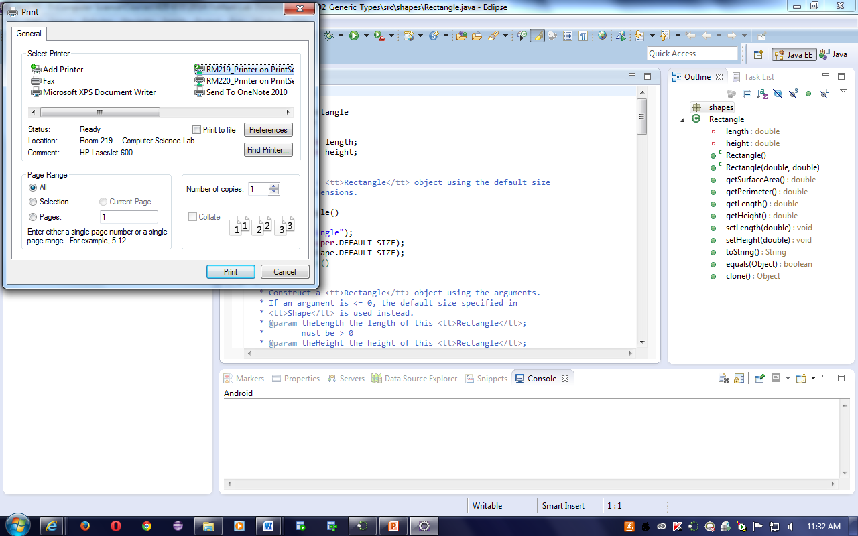

* 1. Identify the equivalence partitions for the “Page Range” section of the box. **(5 marks)**

All – Valid

Selection – valid

Pages / current – Valid

Pages / 1-DOC_LENGTH – valid

Pages / 0-DOC_LENGTH – invalid

Pages / 1-DOC_LENGTH+1 – invalid

Pages / 1 – valid

Pages / DOC_LENGTH – valid

Pages / 0 – invalid

Pages / DOC_LENGTH+1 – invalid

Pages / DOC_LENGTH-1 - valid

* 1. Identify the equivalence partitions for the “Select Printer” section of the box. **(5 marks)**

Add print – invalid

Fax – invalid

Microsoft XPS doc writer – invalid

Send to onenote – invalid

RM_219 – valid

RM_221 – valid

**Part C – Use Case Scenarios**

1. Given the following excerpts from the “Register for Courses” use case narrative below, develop a test case matrix, with the test case ID, condition, data elements, and expected result. Complete the table, using V for valid data, I for invalid data, and N/A where the data element is not applicable for the condition. **(8 marks)**

|  |  |  |  |  |  |  |  |  |  |
| --- | --- | --- | --- | --- | --- | --- | --- | --- | --- |
| ID | Scenario | Username | password | Course registration is open | Course catalog available | Has met prerequisites for course | Course has space | Schedule has No conflicts | Expected output |
| 1 | Happy path | V | V | V | V | V | V | V | Success |
| 2 | Invalid login | I | N/A | N/A | N/A | N/A | N/A | N/A | Fail |
| 3 | Invalid password | V | I | N/A | N/A | N/A | N/A | N/A | Fail |
| 4 | Course reg. closed | V | V | I | N/A | N/A | N/A | N/A | Fail |
| 5 | Catalog not available | V | V | V | I | N/A | N/A | N/A | Fail |
| 6 | Miss prereq. | V | V | V | V | I | N/A | N/A | Fail |
| 7 | Course full | V | V | V | V | V | I | N/A | Fail |
| 8 | Conflicts | V | V | V | V | V | V | N/A | Fail |

1. Copy the matrix. Replace the V’s with valid test case values and the I’s with invalid test case values, assuming that you are trying to register for your Computer Science classes in the fifth semester. **(8 marks)**

|  |  |  |  |  |  |  |  |  |  |
| --- | --- | --- | --- | --- | --- | --- | --- | --- | --- |
| ID | Scenario | Username | password | Course registration is open | Course catalog available | Has met prerequisites for course | Course has space | Schedule has No conflicts | Expected output |
| 1 | Happy path | V | V | V | V | V | V | V | Success |
| 2 | Invalid login | I | N/A | N/A | N/A | N/A | N/A | N/A | Fail |
| 3 | Invalid password | V | I | N/A | N/A | N/A | N/A | N/A | Fail |
| 4 | Course reg. closed | V | V | I | N/A | N/A | N/A | N/A | Fail |
| 5 | Catalog not available | V | V | V | I | N/A | N/A | N/A | Fail |
| 6 | Miss prereq. | V | V | V | V | I | N/A | N/A | Fail |
| 7 | Course full | V | V | V | V | V | I | N/A | Fail |
| 8 | Conflicts | V | V | V | V | V | V | N/A | Fail |

**Register For Courses**

*Basic Flow*

1. **Logon**

This use case starts when a student accesses the Course Registration System.

The system prompts the student to enter a student number and password. The student enters their student number and password.

2. **Select 'Create a Schedule'**

The system displays the functions available to the student. The student selects the option to "Create a Schedule."

3. **Obtain Course Information**

The system retrieves a list of available course offerings from the Course Catalog System, and displays the list to the student.

4. **Select Courses**

The student selects four primary course offerings and two alternate course offerings from the list of available course offerings.

5. **Submit Schedule**

The student indicates that the schedule is complete. For each selected course offering on the schedule, the system verifies that the student has the necessary prerequisites.

6. **Display Completed Schedule**

The system displays the schedule containing the selected course offerings for the student and the confirmation number for the schedule.

*Alternate Flows*

**1. Unidentified Student**

In Step 1 of the Basic Flow, Logon, if the system determines that the student number and/or password is not valid, an error message is displayed.

**2. Quit**

The Course Registration System allows the student to quit at any time during the use case. The student may choose to save a partial schedule before quitting. The schedule is saved in the system. The use case ends.

**3. Unfulfilled Prerequisites, Course Full, or Schedule Conflicts**

In Step 5 of the Basic Flow, Submit Schedule, if the system determines that prerequisites for a selected course are not satisfied, that the course is full, or that there are schedule conflicts, the system will not enroll the student in the course. A message is displayed that the student can select a different course. The use case continues at Step 4, Select Courses, in the basic flow.

**4. Course Catalog System Unavailable**

In Step 3 of the Basic Flow, Obtain Course Information, if the system is down, a message is displayed and the use case ends.

**5. Course Registration Closed**

If, when the use case starts, it is determined that registration has been closed, a message is displayed, and the use case ends.

**To submit**

When you have completed the assignment, upload the document to the Moodle page for this course.